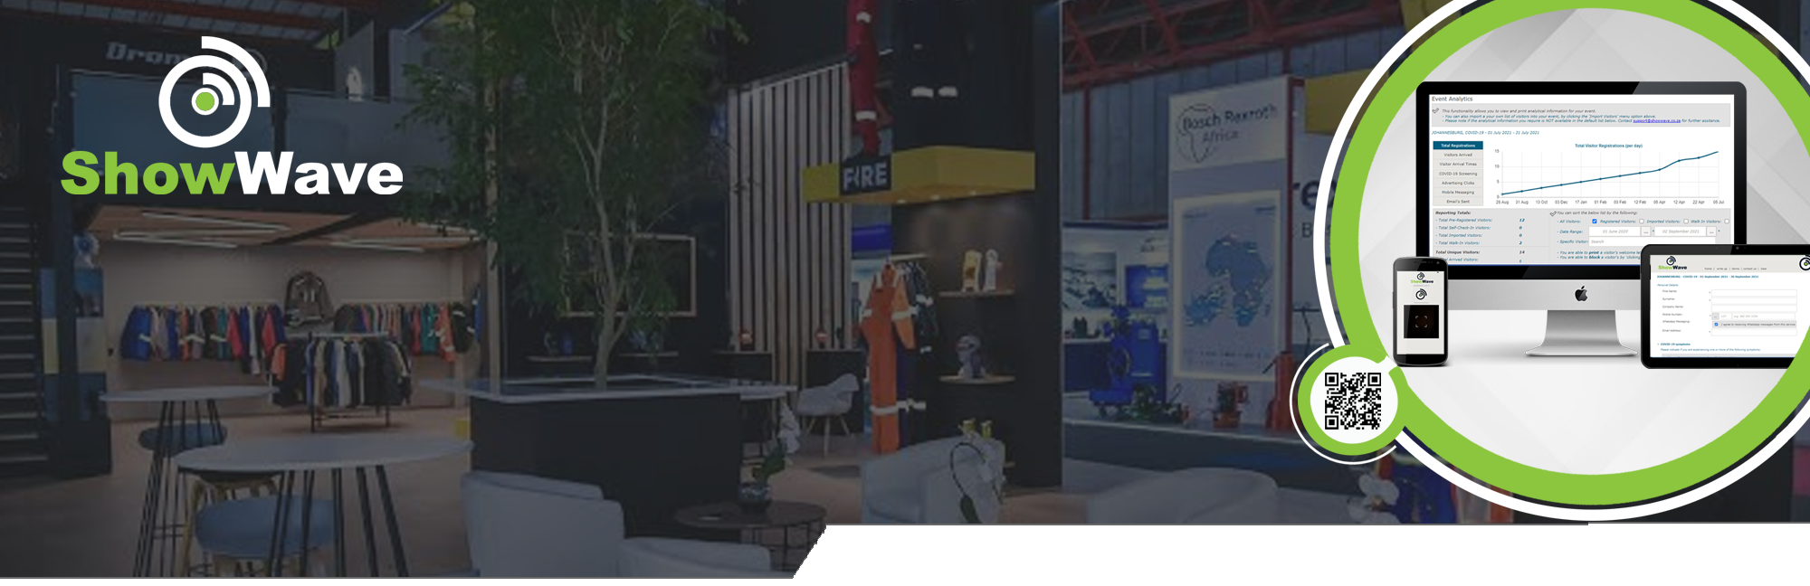
Company Profile

The Company
Country Incorporated: South Africa
Trading Name: RSP Information Technology cc
Registration Number: 2006/134581/23
VAT Number: 4540272244
Summary: RSP Information Technology is a South African-based company established in 2006, with proven success in delivering high-quality, customised web solutions and data management consultation to various southern African-based companies, ranging from SMEs to large enterprise organisations. The company’s consultancy service is a value add and is utilised as an additional revenue stream.
ShowWave is an internally developed product and was introduced into the business as an asset, along with its intellectual property. The offering is maintained, supported and enhanced internally with NO third-party involvement. ShowWave launched into the market as a fully functional solution in September 2022, after an 18-month design, development and POC staggered process.
Websites: RSP Information Technology | ShowWave
Social Media: Facebook | Instagram | LinkedIn
The Value Proposition
ShowWave is a complete, secure, end-to-end, configurable, and functioning online event visitor management solution developed in-house with an estimated replacement value of ZAR 5,324k / USD 350k and is estimated to take 8 months to replicate. The application is web-based and facilitates event and visitor registration, ticket sales and attendance administration with the added advantages of QR Code technology for quicker, hassle-free visitor tracking and tracing, with an option to be utilised for a cashless environment.

ShowWave allows event organisers and organisational bodies the ability to have a secure, online solution to manage their visitor and staffing attendance registry, collect and manage data and provide invaluable analytical and reporting support to stay compliant and grow their business.

ShowWave has been used successfully over the past years in South Africa by corporate entities, exhibitions, marketing, sports and event organisers, to name a few. Sighting that ShowWave is extremely cost-effective and provides a huge amount of value.

However, with today’s hunger for data and what we can do with “big data” (extremely large data sets that may be analysed computationally to reveal patterns, trends, and associations, especially relating to human behaviour and interactions). The ShowWave solution is seen as a portal to collect valid and verified data over a period of time and across an array of clients and visitors, which presents a compelling opportunity to engage with a highly targeted and active audience, ideal for precision marketing and promotional initiatives.
 |  | info@showwave.co.za |  | www.showwave.co.za

The History and Target Customer
RSP Information Technology was established in 2006 and provides IT consultancy services ranging from system design, development, and maintenance to business and data analytics, governance, and management. RSP Information Technology is not averse to its own challenges. In 2020, we had to change the direction of our business due to the Pandemic that presented an uncertain outlook in the consultancy services it offered.

RSP Information Technology has, over the years, developed internal solutions and introduced them as assets into the business along with its IP. One of these assets, ShowWave, proved to be a perfect fit and offering to the global health and safety screening guidelines post 2020 COVID Level 5 lockdown and the reopening of businesses and events to start allowing staff and visitors back onto their property and venues. This had provided the perfect trigger for ShowWave to demonstrate its capability to break into the event industry as a service provider.

Our ideal B2B customer would be:
A business that endorses and promotes the asset on behalf of RSP Information Technology, gaining significant value in reducing administrative expenses, alleviating administrative pain points, saving time and potentially an additional revenue stream, while expanding ShowWave’s sales force and footprint.
Examples:
- RSP Information Technology has already managed to partner with industry associations like PsySSA (Psychological Society of South Africa) and TBCSA (Tourism Business Council of South Africa) to handle their annual congresses for the past 2 and 4 years, respectively. Both utilising ShowWave’s online ticket sale option and processing over R7 million in ticket sales in 2023/24 alone.
- RSP Information Technology has also been onboarded as a service provider to FNB (First National Bank) to assist with the internal and external event registrations, while the travel industry in TTS (Tourvest Travel Services) and the XL Travel Group are adopting ShowWave in their M.I.C.E. (Meetings, Incentives, Conferences and Events) space.
- ShowWave has onboarded over 140 clients, activated over 400 events and processed over 100k unique visitors over the past 3 years.

An ideal B2C customer would be:
A consumer who continuously utilises the asset for regular and multiple events/functions. Therefore, increasing the data intake to fulfil the company’s long-term goal in analysing the data to reveal patterns, trends and associations, especially relating to human behaviour and interactions, increases the company’s offering.

 |  | info@showwave.co.za |  | www.showwave.co.za

.

Founders
Name: Darrin Smart
Position: 100% Main Member
Domicile: South Africa
Background: Darrin has consulted for many of South Africa’s largest financial organisations over the past 25 years, leading and/or being a part of their teams in delivering successful IT-related projects. From development, system, data and business analytics. His strength lies in understanding his role and responsibility to each client, while understanding the importance of the project team and his involvement as a team member to achieve our common objectives in creating a successful project.
Darrin has utilised his experience over the years to design, develop, maintain and support the ShowWave solution.
The Opportunity
The opportunity that we have now?
Currently in the event visitor management space, many of our competitor solutions do not cover a complete end-to-end solution, meaning their pre-event, at-event and post-event processing is fragmented or non-existent. While ShowWave offers this complete process in a configurable environment that meets and supersedes our client’s expectations in turnaround time for delivery, while ensuring validity and verification of visitor information.
Scalability of the opportunity?
The long-term strategy is to retain existing clients on a subscription basis and onboard new clients through brand awareness. These organisations and event organisers fulfil their other core business requirements in either staff timekeeping and attendance or event visitor management.
Our long-term goal is to become the leader into event insights, visitor patterns, trends, associations, behaviour and interactions through data analytics and data science.
The Industry
South Africa
South Africa's meetings, conventions and exhibitions industry is an important sector to attract foreign visitors and investment. In 2019, 11.4% of foreign tourism was attributed to this industry, where an average of one million business delegates are hosted annually.
South Africa is ranked number one in Africa in the International Congress and Convention Association rating.
There are more than 84 registered sporting federations in South Africa listed on the Sports and Recreation Department of South Africa’s website. Each one of these federations have clubs, members and events that event organisers target to manage.

 |  | info@showwave.co.za |  | www.showwave.co.za

International
The event management software market was valued at USD 9.13 billion in 2020 and is expected to reach a value of USD 16.71 billion by 2026, registering a CAGR of 10.65% over the forecast period 2021 - 2026.

The event management software market was valued at USD 9.13 billion in 2020 and is expected to reach a value of USD 16.71 billion by 2026, registering a CAGR of 10.65% over the forecast period 2021 - 2026.

Event management software has become a standard for both large-scale and small-scale planners. An increasing number of professional and freelance organisers have bolstered the demand for application-based services in the past few years. Event management software solutions are highly beneficial for third-party planners compared to in-house planners, as third-party planners handle multiple events or shows that occur at any time of the year.
• The factors influencing the market growth are the significant increase in the number of events in sports, gaming, and entertainment sectors over the past decade and widespread adoption of software that can be used to streamline the events from start to end, based on both historical and real-time data.
• As events are turning out to be great marketing channels, vendors and marketing firms are increasingly looking for collaborations with event organisers. In fact, according to Social Tables, in a recent event marketing survey, 52% of respondents mentioned that event marketing drove more business value to them than other marketing channels. Such statistics are further encouraging the market entry of new players, increasing the demand for mobile-based event management software solutions.
• With the changing lifestyles of the people, innovations have arisen in hosting events. Further companies and consortia have focused on hosting theme-based meetings and events at attractive destinations to increase their brand image. Based on the research of the Experience Institute, a whopping 71% of people consider the destination in the decision to attend a meeting. Beyond that, 20-30% say it’s the deciding factor.

Furthermore, the growing organisation of social events, such as awareness gatherings, social service, and fundraising events, even those planned by SMEs for marketing purposes, is boosting the demand for event management software.

(Above market analysis is provided by Mordor Intelligence www.mordorintelligence.com).

The Underserved Market
ShowWave’s analytical capability can and will assist not only event organisers but also industries in general with insights and the behaviours of individuals. One of the key objectives is for ShowWave to be able to provide significant information related to areas that can be developed or utilised, with opportunities for growth and inclusion into groups of people that have previously been overlooked.
The Product
Product: ShowWave
GP%: 100%
Comment: Subscription and per-event based, and owned 100% by RSP Information Technology
 |  | info@showwave.co.za |  | www.showwave.co.za

The Customer
ShowWave is a highly configurable online Visitor Management solution that is suitable for organisations, including event-based and non-event-based entities.

Current industry segments:
- Event Organisers
- Marketing Agencies
- Travel Agencies
- Industry Societies
- Financial Organisations
- Real-Estate Agencies
- Hospitality accommodation
- Corporate Entities
- Sport Entities.
Our customers are organisations that want to improve the process of their visitor management operations by including a digital solution to ensure that secure and accurate information is captured, stored and utilised to comply with guidelines or assist and build on their core business objectives.

Distribution Channels and Contribution to Revenue
ShowWave is a cloud-based B2B / B2C solution offering. Current contribution to revenue is 100%.
Revenue Contribution by Channel:
Online Sales: 0% of total sales
Direct Sales: 100% of total sales
Customer Acquisition and Retention:
- Which Channels do you use to acquire new customers?
  - Reseller channels
  - Partnership agreements
  - Existing relationships
  - Email campaigns
  - Social media marketing & advertising
  - Positive word of mouth and referrals

- How much does it currently cost you to acquire one customer, and is there a way to bring it down?
  - ShowWave – currently the CAC (Customer Acquisition Cost) is estimated at R195 per customer, however, this excludes staff salaries.
Once traction is achieved and sales targets are achieved, there will be a significant decrease to around R14 per customer in the first year.
 |  | info@showwave.co.za |  | www.showwave.co.za

- Which channels have proven to be the most successful for new customers?
  - Direct contact with the product and referrals
  - Word of mouth
  - Partnership agreement promotions

- How sticky are customers – how many times do they trade with you on average?
  - The current process for acquiring a new customer is to provide a 30-minute training session on the platform. Once this is completed, the only interaction with the customer is if there is an issue to report or support needed.
The Supplier, Partners and Competition
Key Suppliers:
- Twilio: SMS & WhatsApp Delivery Services | website
- SendGrid: Email Campaign & Delivery Service | website
- PayFast: Online Payment Gateway Service for ticket sales | website
- Afrihost: Dedicated Cloud Hosting Service | website
Dependency
Is the organisation dependent on any third parties?
- ShowWave is an in-house developed solution by RSP Information Technology, so there is no dependency on a development and support supplier to maintain the solution.
- The only dependency is with the key suppliers listed above.

Competitors and Market Leaders
List the top competitors in this industry LOCALLY:
Although there are an array of competitor solutions, these are the list of the solutions most commonly referred to:
Competitors:
- Event Options | website
  - What Element Do They Lack: Solution’s ticket sale process lacks the process for visitors to request quotes, invoices and provide purchase orders for delegates wishing to attend events that their companies pay. They also outsource exhibition visitor matching and lead management to other suppliers.

- EventsAir | website
  - What Element Do They Lack: One of the industry's larger service providers, however, their cost and turnaround time are unsatisfactory to the majority of the South African market.

- Google Docs | website
  - What Element Do They Lack: On-site capability, no full visitor management offering end-to-end

 |  | info@showwave.co.za |  | www.showwave.co.za

We are disrupters and here’s why…
- Once adopted by many event organisers, visitors will drive their own attendance with their QR Code identification.
- The platform has passive income functionality for our clients through on-screen advertising.
- The platform allows for primary and secondary access control, meaning a primary client can grant secondary access to other event organisers to run events through the primary profile.
- The platform is dynamic in nature and accommodates any visitor management requirements a client requires.
Staffing
Additional staff will be required over time to further develop and enhance ShowWave and build a sales force.

Head Count:
- Top Management
  - Current: 1 | Y/E 2025: 1 | Y/E 2026: 1
- Employee
  - Current: 0 | Y/E 2025: 1 | Y/E 2026: 2

Staffing is to include finance and compliance, marketing, sales, and additional technical resourcing.

Management
Finance
Jackie Ward
Technology
Darrin Smart
Marketing & Sales
Vacant

Combined
Web Developer
Vacant
Marketeer
Vacant
Registration Staff
Casual
Sales Rep
Vacant
Mobile Developer
Vacant
Data Intelligence
Vacant

The Vision
The vision is to supply a leading-edge, user-friendly and valuable information event visitor management solution. Our immediate goal is to gain traction in the market, with the long-term goal of becoming the leader in event management, insights, visitor patterns, trends, associations, behaviour and interactions through data analytics and data science.
 |  | info@showwave.co.za |  | www.showwave.co.za

Trusted By
ShowWave’s user-friendly and flexible platform is trusted by venues, marketing and travel companies, restaurants, and event planners to manage their visitor management journeys with ease:
 | While the Tourvest Travel Service’s M.I.C.E (Meetings, Incentives, Conferences and Events) department trusts ShowWave for all their visitor RSVP, Registration and On-site visitor management needs, the greater group utilise the platform for the head office venue visitor booking and arrival tracking needs.  Current Registration Sites: Travel
 | Sign Africa delivers the latest news, insights, and trends in wide format, garment and textile printing, branding, and all aspects of visual communication in South Africa. Along with Africa Print, Graphics/Signs/Print, and Modern Marketing host over five industry exhibitions across South Africa, utilising the ShowWave offering over the past 3 years for more than 10,000 annual visitor registrations, tracking, and tracing. These events also provide exhibitors with the added benefit of lead management scanning.  Current Registration Sites:
  SignAfrica | AfricaPrint | GPS | ModernMarkerting
 | The Tourism Business Council of South Africa is an organisation that fosters and supports collaborations between the private and public sectors to achieve shared tourism industry growth goals, enhance traveller confidence in Destination South Africa, and promote a sustainable travel and tourism industry. Over the past three years, and continuing annually, they have relied on ShowWave for their tourism leadership conference. ShowWave supports their visitor registrations, tracking, and tracing requirements for over 800 attendees each year.  Current site: TBCSA

 |  | info@showwave.co.za |  | www.showwave.co.za

 | The Society’s commitment to academic excellence is demonstrated through its publication of the South African Journal of Psychology, a quarterly journal that is regarded as the leading psychology periodical on the African continent. Over the past two years, they have relied on ShowWave for their annual psychology congress. ShowWave assists with visitor registrations, online ticket sales, CPD tracking, and tracing requirements for over 900 delegates each year.
 | Established in 2007, UP A TONE EVENTS has evolved beyond traditional event entertainment to become a comprehensive corporate event planning agency. With a wealth of experience spanning thousands of events, they excel in creating memorable experiences for audiences of up to 4,500 attendees. UP A TONE EVENTS trusts ShowWave as their visitor RSVP, Registration and On-site attendance partners. Including the ShowWave offering in all their event planning tenders.  Their website
 | At Penquin they are the creators of brand stories, the collaborators, the conversation starters and idea generators. In the realm of brand and communication, evolution is key. The agency prides itself on staying ahead of the curve, offering various solutions across diverse media channels. Penquin trusts ShowWave as their visitor RSVP, Registration and On-site attendance partners. Including the ShowWave offering in all their event planning tenders.  Their website
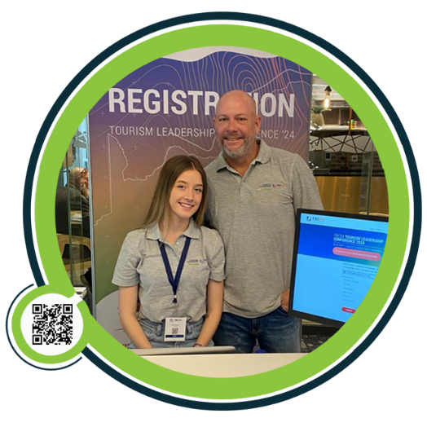 |  | Thank You
Darrin Smart
Founder & Product Owner
M: +27 (0)82 857-7326
E: darrin@showwave.co.za

 |  | info@showwave.co.za |  | www.showwave.co.za

