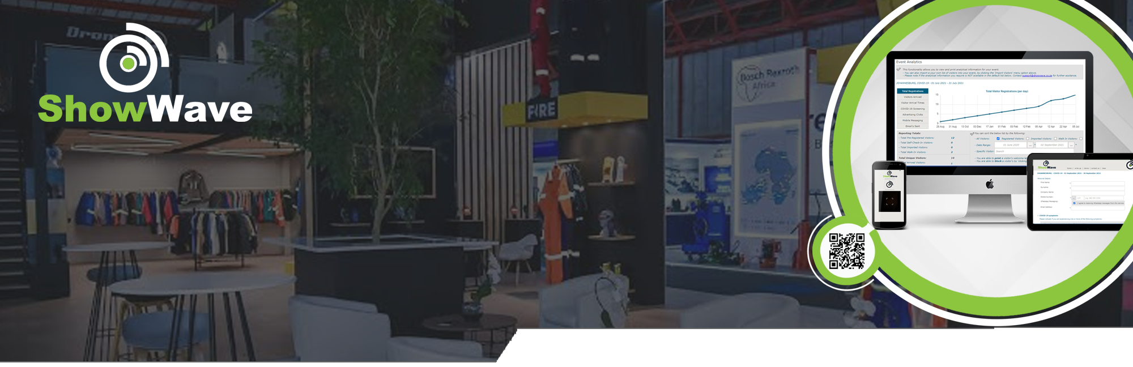
This Data Protection & Privacy Policy ("Policy") describes how RSP Information Technology ("ShowWave", "we", "us", "our") collects, processes, stores, and protects personal information when clients and their end-users utilise the ShowWave online event visitor management platform, accessible at www.showwave.co.za ("Platform").
Data Protection & Privacy Policy
This Policy is drafted in accordance with the laws of the Republic of South Africa, including the Protection of Personal Information Act, 4 of 2013 (POPIA).

1. PURPOSE
The purpose of this Policy is to:
- Ensure transparency regarding the processing of personal information;
- Outline RSP Information Technology’s data protection practices;
- Confirm compliance with POPIA and applicable data protection laws.

2. DEFINITIONS
- "Personal Information" has the meaning assigned to it in POPIA and includes any information relating to an identifiable, living natural person or juristic person.
- "Client" means any entity or individual that licenses or uses the Platform.
- "Data Subject" means the person or entity to whom Personal Information relates.
- "Processing" has the meaning ascribed to it in POPIA and includes the collection, storage, use, and deletion of Personal Information.

3. ROLES AND RESPONSIBILITIES
3.1 RSP Information Technology (ShowWave) as Operator
RSP Information Technology (ShowWave) generally acts as an operator (as defined in POPIA) when processing Personal Information on behalf of its Clients.
3.2 Client as Responsible Party
The Client is the responsible party for Personal Information collected via the Platform and determines the purpose and means of processing such Personal Information.

4. PERSONAL INFORMATION PROCESSED
Depending on the Client’s use of the Platform, RSP Information Technology (ShowWave) may process the following categories of Personal Information:
- Names and surnames
- Email addresses and contact details
- Identification or registration numbers (where required by the Client)
- Event attendance, registration, and participation data
- Device, browser, and usage information
RSP Information Technology (ShowWave) does not intentionally process special personal information unless expressly required by the Client and permitted by law.

5. PURPOSES OF PROCESSING
Personal Information is processed for the following purposes:
- Event registration and visitor management
- Verification of attendees and access control
- Communication relating to events
- Reporting and analytics for Clients
- Platform security, auditing, and operational support

6. LAWFUL BASIS FOR PROCESSING
RSP Information Technology (ShowWave) processes Personal Information in accordance with POPIA on the basis that:
- Processing is necessary to perform in terms of a contract with the Client;
- Processing is required to comply with a legal obligation; and/or
- Data Subjects have provided consent where required.

7. CLIENT OBLIGATIONS
Clients warrant and undertake that they:
- Have a lawful basis to collect and process Personal Information;
- Have obtained all necessary consents from Data Subjects;
- Provide appropriate privacy notices to Data Subjects;
- Use the Platform in compliance with POPIA and other applicable laws.

8. DATA SECURITY SAFEGUARDS
RSP Information Technology (ShowWave) implements appropriate, reasonable technical and organisational measures to protect Personal Information against:
- Loss or damage;
- Unauthorised access, processing, or disclosure;
- Unlawful processing.
Such measures may include access controls, encryption, secure hosting environments, and regular system monitoring.

9. DATA RETENTION
Personal Information is retained only for as long as necessary to:
- Fulfil the purposes for which it was collected;
- Comply with legal or contractual obligations; or
- As instructed by the Client.
Upon termination of services, Personal Information may be returned to the Client or securely deleted, subject to applicable law.

10. DATA SUBJECT RIGHTS
In accordance with POPIA, Data Subjects have the right to:
- Request access to their Personal Information;
- Request correction or deletion of Personal Information;
- Object to the processing of Personal Information;
- Lodge a complaint with the Information Regulator of South Africa.
Requests relating to Personal Information processed via the Platform should be directed to the relevant Client, as responsible party.

11. DATA BREACH MANAGEMENT
In the event of a suspected or confirmed security compromise affecting Personal Information, RSP Information Technology (ShowWave) shall:
- Notify the relevant Client without undue delay; and
- Provide reasonable assistance to enable the Client to comply with its notification obligations under POPIA.

12. CROSS-BORDER DATA TRANSFERS
Where Personal Information is transferred outside of South Africa, RSP Information Technology (ShowWave) shall ensure that such transfers comply with section 72 of POPIA and that appropriate safeguards are in place.

13. THIRD-PARTY SERVICE PROVIDERS
RSP Information Technology (ShowWave) may utilise third-party service providers (such as hosting or infrastructure providers) who process Personal Information on its behalf. All such providers are required to maintain appropriate data protection and security standards.

14. CHANGES TO THIS POLICY
RSP Information Technology (ShowWave) reserves the right to update this Policy from time to time. Any material changes will be communicated via the Platform or other appropriate means.

15. CONTACT DETAILS
For queries relating to this Policy or data protection matters, please contact:
RSP Information Technology cc
Email: info@showwave.co.za

Effective Date: ____________________

